* **BREAKING**



Red Sox 10, Braves 8, Final



**Fios Home Internet starting at $39.99/mo.**

W/ Auto Pay + taxes & equip charges. For 200/200 Mbps.

**Get Fios**

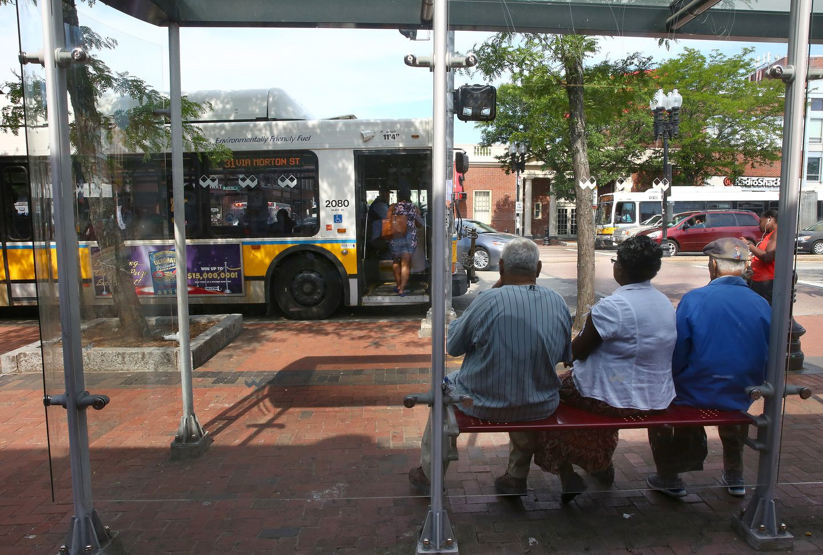

**Underserved in transit, Mattapan**

**wants a lift**

**By Meghan E. Irons** Globe Staff, July 25, 2016, 7:10 a.m.

**22**

Mattapan’s only mass-transit options are a slow trolley to Ashmont Station and glacial-paced buses. PAT GREENHOUSE/GLOBE STAFF

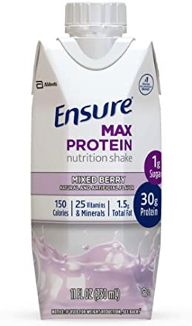

*30g protein and nutrients to support immune health*

10% off coupon

Ensure Max Protein Nutritional Shake with…

The city bus hissed, then stopped in front of a dollar store in Mattapan Square, where a mid-morning crowd clambered aboard for destinations across Boston.

For the passengers, the Route 28 bus is part of the daily grind that comes with living in Mattapan, a community of 24,000 at the southern tip of Boston. The bus has become a slow-moving symbol of the lack of easy access to the rest of the city.

In many parts of Boston, residents have the quick option of walking to stations with fast-moving trains. In Mattapan, the only mass- transit options are a slow trolley connecting to Ashmont Station and glacial-paced buses.

Advertisement

# BOSTON GLOBE VIDEO



2:23

Baker announces ‘VaxM SHARE

“It’s not quick,’’ said Robert Jenkins, a longtime Mattapan resident and advocate, of the trolley. “It doesn’t run regularly, and it gets worse on the weekend.”

A crosstown trek from Mattapan can last more than 40 minutes on buses such as Route 28, which connects to the better-paying jobs in the Longwood Medical Area.

**s ns’**

**rd**

Governor Charlie Baker announced residents who are fully vaccinated against COVID-19 will have the chance to win $1 million in a special Lottery sweepstakes. (Photo by Matt Stone/Boston Herald via AP)

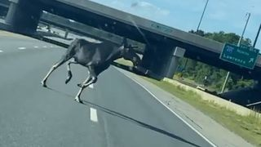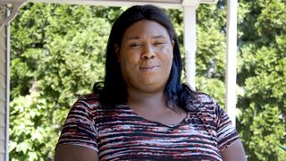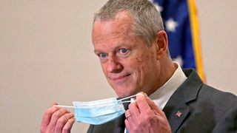

**Baker**

**Moose What**

**announce spotted Black ‘VaxMillio on liberation lottery Route 3 means program in to me:**

**Chelmsfo Athena**

**Vaughn**

**NOW PLAYING**

Get Today's Headlines in your inbox

The day's top stories delivered every morning.

Enter Email

[example@email.com](mailto:example@email.com)

**Sign Up**

“It takes too long,’’ Uret Nelson grumbled before she boarded. “We need a quicker bus.”

Such concerns are being considered in a new city calculus called Go Boston 2030, which aims to reimagine the future of transportation in Boston. Since the fall, officials have been collecting residents’ transportation policy and projects ideas. Those ideas will be folded into a comprehensive plan and implemented over the next five, 10, and 15 years, said Boston transportation officials, who are teaming with the state on the initiative.

Given the current fiscal woes of the Massachusetts Bay Transportation Authority, it’s unclear how much financial help the T will provide for upgraded systems to Mattapan or other neighborhoods in Dorchester and Roxbury that have few mass transit options. Spokesman Joseph Pesaturo said no funds are allocated for such a project in the agency’s recently approved five-year capital investment program.

Advertisement

But city officials said at this stage in the planning, they are less concerned about cost and are instead aiming to chart what the city eventually needs to best move people around. One focus, those officials say, is bringing faster transit services to these low-income areas.

**MOST POPULAR ON BOSTONGLOBE.COM**

1. Message in a bottle, tossed into the sea in Rhode Island, found in Azores
2. Baker announces ‘VaxMillions’ lottery program, offering $1 million cash prizes to boost vaccination rates
3. Life sciences is poised to be Boston’s dominant industry. Has the area become the Silicon Valley of biotech?
4. ‘Boo Boo’ the South Shore Bear captured on video roaming in Duxbury
5. Study says COVID-19 was likely present in Mass. as early as December 2019
6. America's blind spot: Thousands of drivers shouldn't be licensed
7. Red Sox hit four homers to put away Braves
8. A treasure map for an American tyrant
9. The downside of ditching masks: the return of colds, flu
10. State licensing loopholes keep thousands of bad drivers on the road

“You still have folks in the heart of the African-American community without a major transportation hub. . . and that needs to be discussed,’’ said State Representative Russell Holmes, who is cochairman of the Go Boston 2030 committee.

Mattapan is a diverse neighborhood of committed homeowners, tree-lined streets, quiet trails, and scenic nooks. But it is also a community with a struggling economic center. It does not have a single restaurant with wine or alcohol on the menu, and it is pocked with areas hit hard by violence.

The neighborhood has been striving to overcome such obstacles, working to build civic activism and pride. Soon city crews will plan trees on the square and broaden the sidewalks. Officials also are working to boost businesses.

Holmes said he welcomes progress in Mattapan, where he lives. Mattapan is set for a new stop on the Fairmount commuter rail line at Woodhaven Street that Holmes said would bolster development nearby and improve the community.

It’s time to figure out how to expand such faster transit options, such as quicker buses in designated lanes free of other vehicles, he added.

Officials are considering ways to bring faster transit services to low-income areas of the Mattapan section of Boston. PAT GREENHOUSE/GLOBE STAFF

Historically, he said, residents in more affluent neighborhoods were given more and better options for public transit. Now, Holmes said, additional resources should be devoted to Mattapan and other underserved communities.



**VIEWS FROM OUR COLUMNISTS**

**YVONNE ABRAHAM**

Energy efficiency is a low- hanging fruit to combat climate change. So why can’t everyone get access to it?

**KEVIN CULLEN**

Bill Bratton on American policing and the challenge facing the Boston Police Department

**THOMAS FARRAGHER**

A salute across the ages to an old squad leader

**SHIRLEY LEUNG**

A working mother’s manifesto: Pandemic provides a once-in-a- generation chance to course correct how we work

**JENEÉ OSTERHELDT**

Juneteenth and the meaning of Black liberation in Boston

**ADRIAN WALKER**

‘The best Boston movie no one’s ever seen’: ‘Blue Hill Avenue’ at 20

Advertisement

Mattapan buses transport 26,000 people to their destinations each weekday, according to MBTA data.

As part of its outreach to the public, the city asked commuters in a monthlong online survey whether they might prefer other options: What about a streetcar or quicker bus transit from Mattapan to Longwood Medical Area or a streetcar to Dudley Square? Or smart-signal corridors on Blue Hill Avenue and other major thoroughfares such as Morton Street?

Faster bus service would curb delays by allowing passengers to pay before they board, and may include building a designated middle lane from Mattapan to Ruggles Station, officials said.

But those details — along with the costs — have yet to be ironed out.

Gina Fiandaca, Boston’s transportation department commissioner, said one of the guiding principles of the initiative is to bring equity to disadvantaged neighborhoods and correct transportation infrastructure gaps in these areas.

“It’s clearly emerged to us that Mattapan is one of our underserved neighborhoods and a key initiative in the transportation department is to work on improving mobility access for residents of Mattapan to other parts of the city,’’ Fiandaca said.

More than 3,800 Boston residents responded to the survey on Go Boston 2030 website, including 28 from people with the Mattapan ZIP code of 02126, transportation officials said.

The small number of responses is indicative of the disconnect between Mattapan and the city, long criticized for poor outreach to its low-income communities, Jenkins, the Mattapan advocate, said. But transportation officials have said they actively solicited community input throughout the process.

Advertisement

“Traditionally, Mattapan residents don’t go to those meetings,’’ said Jenkins, who was not aware of the survey.

More than 500 of the online responses were in favor of the streetcar/bus rapid transit option from Mattapan to the Longwood Medical Area. And more than 1,500 people supported smart traffic signal corridors.

The responses will be incorporated in the city action plan that will be released this fall.

Until then, the residents of Mattapan will continue to wait.



There are few speedy transportation options for Mattapan residents trying to get to other parts of the city. ADITI BHANDARI/GLOBE STAFF

[Meghan E. Irons can be reached at meghan.irons@globe.com. Follow her](mailto:MeghanE.Ironscanbereachedatmeghan.irons@globe.com.Followher) on Twitter @meghanirons.

**Show 22 comments**

**MORE ON GLOBE.COM**

# PROVIDED BY: PEABODY ESSEX MUSEUM

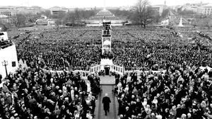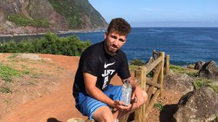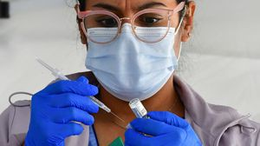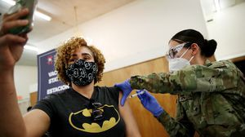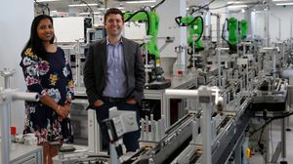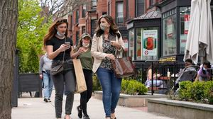

## Consider the sea through a new lens

The paintings at PEM’s new exhibit deepen understanding of the sea as a symbol of opportunity and invention.

## A treasure map for an American tyrant

Donald Trump exposed weaknesses that a would-be dictator could exploit to end our democracy. It’s now up to lawmakers, voters, and public officials to prevent that from happening.

# RI NEWS

## Message in a bottle, tossed into the sea in Rhode Island, found in Azores

The note was written in 2018 by a 13- year-old who was visiting family in Rhode Island.

# OPINION

## I got the Johnson & Johnson vaccine. The pause makes me believe in it more.

The worst thing that could happen now is for the recommendation by the FDA and CDC to pause the vaccine’s administration to spur a new wave of vaccine hesitancy.

## 5 things to know about the VaxMillions lottery sweepstakes in Mass.

Here are five things you should know about the VaxMillions program, which will make some lucky winners living proof that trusting the science really does pay.

# INNOVATION ECONOMY

## Life sciences is poised to be Boston’s dominant industry. Has the area become the Silicon Valley of biotech?

Since December, you can find six major indications that Boston is the undisputed center of the life sciences industry, a place where ideas and products that change ― and save ― people’s lives around the world originate.

## ‘Boo Boo’ the South Shore Bear captured on video roaming in Duxbury

Duxbury police said on Twitter that a resident living on Elm Street spotted Boo Boo in the backyard around 8:30

a.m. Tuesday, eating birdseed.

## Death penalty should be reinstated for Tsarnaev in Boston Marathon bombings case, Biden administration tells Supreme Court

The Biden administration is asking the Supreme Court to reinstate the death penalty against Dzhokhar Tsarnaev for the Boston Marathon terror bombings.

**America's blind spot: Thousands of drivers shouldn't be licensed** A Boston Globe investigation of how bureaucratic negligence has left lethal drivers on the road.

**The downside of ditching masks: the return of colds, flu** Since the state’s mask mandate was lifted, face coverings have started to come off — and stay off. But according to infectious diseases doctors, the return of facial freedom might come with some downsides, like a resurgence in cases of the common cold and the flu.

**METRO SPORTS BUSINESS & TECH OPINION**

WELCOME, JOHN

**TODAY'S PAPER**

**Check out this week's virtual events**

RSVP now

**LAWMAKERS STRIKE DEAL TO RESTORE PANDEMIC-ERA POLICIES, INCLUDING EVICTION PROTECTIONS, TO-GO COCKTAILS**

**MOST READ IN THIS SECTION**

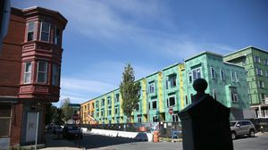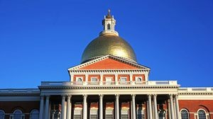

**America's blind**

**spot: Thousands of drivers shouldn't be licensed**

**RI NEWS**

**Message in a bottle, tossed into the sea in Rhode Island, found in Azores**

**Death penalty**

**should be reinstated for Tsarnaev in Boston Marathon bombings case, Biden administration tells Supreme Court**

**‘Boo Boo’ the South**

**Shore Bear captured on video roaming in Duxbury**

**With housing at**

**center of Boston mayor’s race, labor and developers are organizing to push candidates**

**5 things to know**

**about the VaxMillions lottery sweepstakes in Mass.**

**State licensing**

**loopholes keep thousands of bad drivers on the road**

**Lawmakers reach**

**compromise on restoring pandemic era-policies including to-go cocktails, outdoor dining**

**Judge reinstates domestic violence charge**

**against Boston police officer**

# FOLLOW US

**SUBSCRIBE NOW MY ACCOUNT CONTACT MORE**



Digital Access

Home Delivery Gift Subscriptions

Log In

Manage My Account Customer Service

Help & FAQs

Globe Newsroom Advertise

Newsletters / View The EPaper /

Order Back Issues / News In Education / Search The Archives / Privacy Policy / Terms Of Service / Terms Of Purchase / Work At Boston Globe Media /

Do Not Sell My Personal Information

©2021 Boston Globe Media Partners, LLC